**Project Design Document**

**Project Title:** Smart AI Cover Letter Generator

**1. Introduction**

This project is a web-based application designed to automate the creation of personalized cover letters using AI. The system provides two main modes—form-based and resume-based—allowing users to generate professional cover letters tailored to specific job descriptions and personal profiles. The platform is built with a focus on usability, security, and integration with modern career development workflows1.

**2. Objectives**

* Enable users to quickly generate high-quality, tailored cover letters for job applications.
* Support both manual (form-based) and automated (resume-based) input methods.
* Provide customization options for tone and content.
* Ensure data privacy and a seamless user experience1.

**3. System Architecture**

**3.1 High-Level Overview**

* **Frontend:** Built with Streamlit for an interactive, responsive web interface.
* **Backend/AI Engine:** Utilizes Google Generative AI (Gemini) for natural language generation.
* **Integration Layer:** Supports file uploads (PDF resumes), environment variable management, and API key security.
* **Data Handling:** Uses Python libraries for PDF parsing and environment management.

**3.2 Component Breakdown**

| **Component** | **Description** |
| --- | --- |
| User Interface | Streamlit-based navigation, forms, and result display |
| AI Engine | Google Generative AI (Gemini) for cover letter generation |
| File Handling | PDF upload and parsing for resume-based mode |
| Security Layer | API key management via environment variables |

**4. Key Features**

* **Form-Based Cover Letter:** Users input personal and job details via a form; AI generates a cover letter based on structured data.
* **Resume-Based Cover Letter:** Users upload a PDF resume and job description; AI analyzes both to create a tailored letter.
* **Tone Selection:** Users can choose from multiple tones (Formal, Friendly, Persuasive, Confident).
* **Download Option:** Generated cover letters can be downloaded as text files.
* **Error Handling:** User-friendly error messages for missing API keys or incomplete inputs1.

**5. User Flow**

1. **Home Page:** User selects between form-based or resume-based cover letter generation.
2. **Form-Based Mode:** User fills out a form with personal, job, and project details, selects tone, and submits.
3. **Resume-Based Mode:** User uploads a resume (PDF), enters job description, selects tone, and submits.
4. **AI Generation:** The system processes inputs and generates a cover letter.
5. **Review & Download:** User reviews the generated letter and downloads it if satisfied1.

**Use Case Diagram**

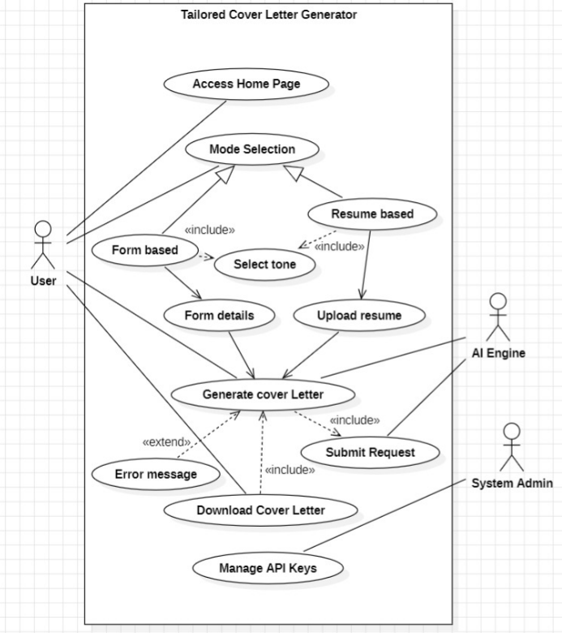

**6. Design Considerations**

* **User-Centric Design:** Simple navigation with sidebar buttons and clear instructions.
* **Accessibility:** Streamlit ensures compatibility across devices and browsers.
* **Security:** API keys are managed via environment variables; no sensitive data is stored long-term.
* **Scalability:** Modular code structure allows for future feature expansion (e.g., more input modes, additional AI models).

**7. Conclusion**

The Smart AI Cover Letter Generator is designed to provide a seamless, secure, and user-friendly experience for generating personalized cover letters. Its modular architecture, robust AI integration, and focus on user needs ensure that it is both practical and scalable for future enhancements